Robert Herrera’s Wifi Speed Test
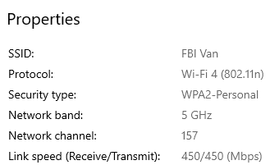
I checked the wifi security type by going to my settings and clicking on my wifi to find the details

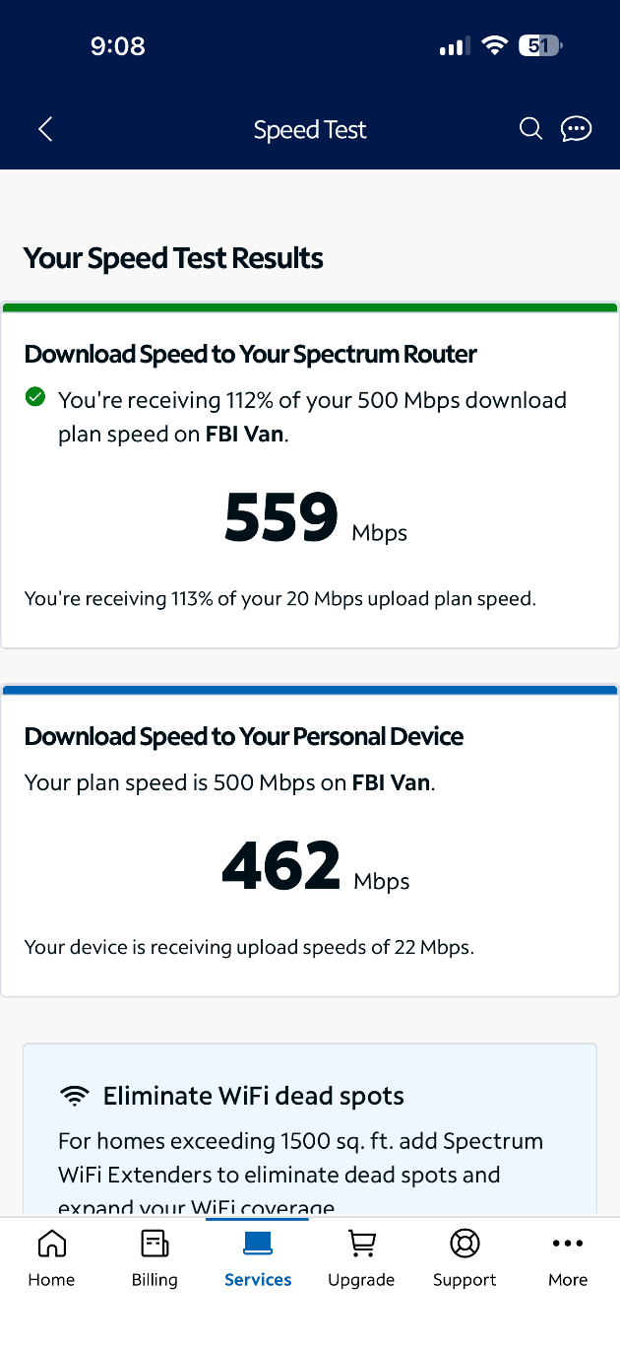
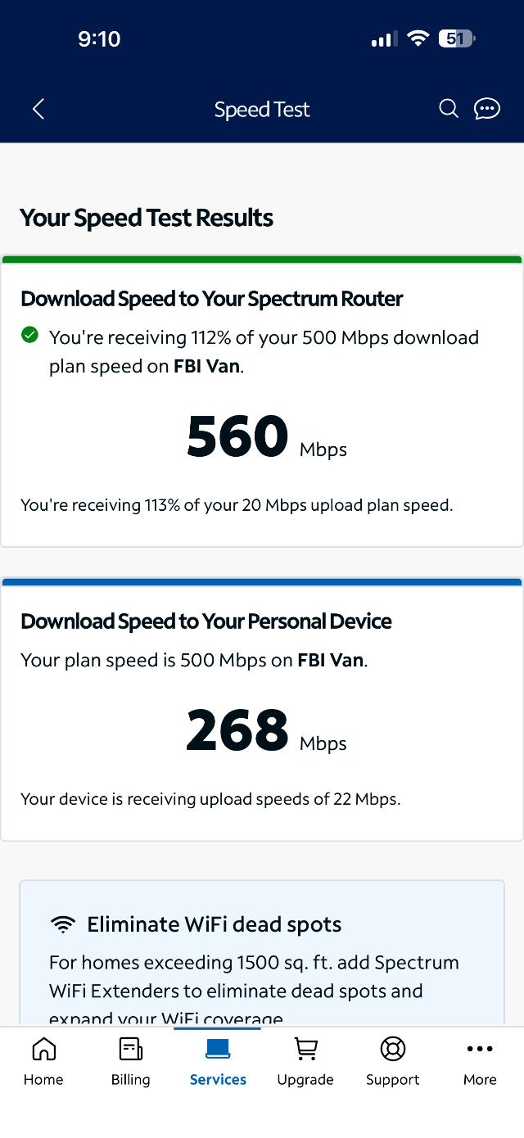
On the right is the speed at 1 foot from the router and on the left it is about 60 feet behind 5 walls there is quite a significant difference almost twice the speed. The throughput is not exactly what how much is on my plan but that may be because I have other devices connected using bandwidth

